User Manual

5e Character Forge Application

Table of Contents

1. Overview3
2. Getting Started3
3. Character Creation4
4. Character Maintenance4
5. Maintaining Settings6

# Overview

In Dungeons and Dragons, or D and D for short, players use character sheets to track their important information regarding their in game character (such as name, level, stats, and skills). Unfortunately, these character sheets are primarily in print, and those few online compatible character sheets are subpar at best. This makes it more tedious and time-consuming, since players are required to monitor their characters in a manual style, as they need to perform actions such as leveling up, monitoring currency, and rolling dice. In order to combat this problem, the 5e Character Forge application was created. This application places emphasis on being able to monitor created characters in an efficient manner. In addition, 5e Character Forge allows for the storing and managing of multiple characters, making it easier to keep track of characters if one is playing multiple games without having to keep track of physical pieces of paper. This application is supplemental to the D and D 5th edition player’s handbook, created by Wizards of the Coast. As such, the application serves to replace only the character sheet used to track character progression, not the book itself. The following documentation describes how to use the application, which includes, but is not limited to, launching the application, creating characters, and frequently asked questions.

# Getting Started

1. Launch Screen

When beginning the 5e Character Forge application, the user is brought to a splash screen:



The user can continue by pressing any key, which will redirect him or her to the start menu of the application.

1. Start Menu

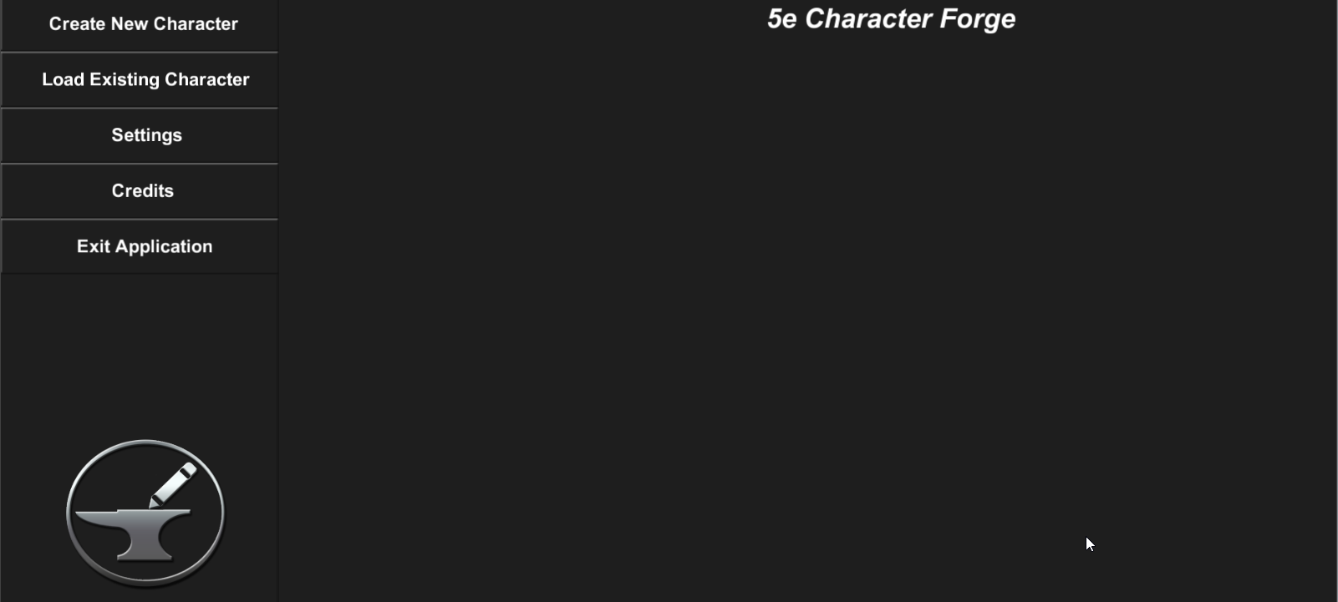

While in the start menu, the user has the following options:

* Create New Character – begin the creation process for a new character
* Load Existing Character – load all saved existing characters so the user may select which one to load
* Settings – screen in which the user can maintain universal settings, such as background music volume and whether the application mode is online or offline
* Credits – acknowledgements in regard to who worked on the application and crediting others for the use of their resources
* Exit Application – enables user to end the application

1. Credits

In order to view the credits of the application, the user can select the credits button in the start menu (see below).

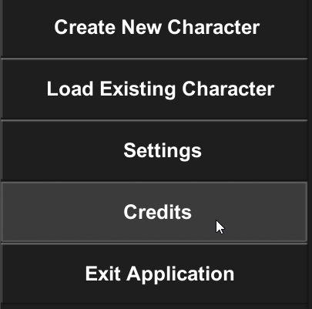

While viewing the credits, the user can opt to go back to the start screen or wait until the credits finish rolling to be automatically returned to the start screen.

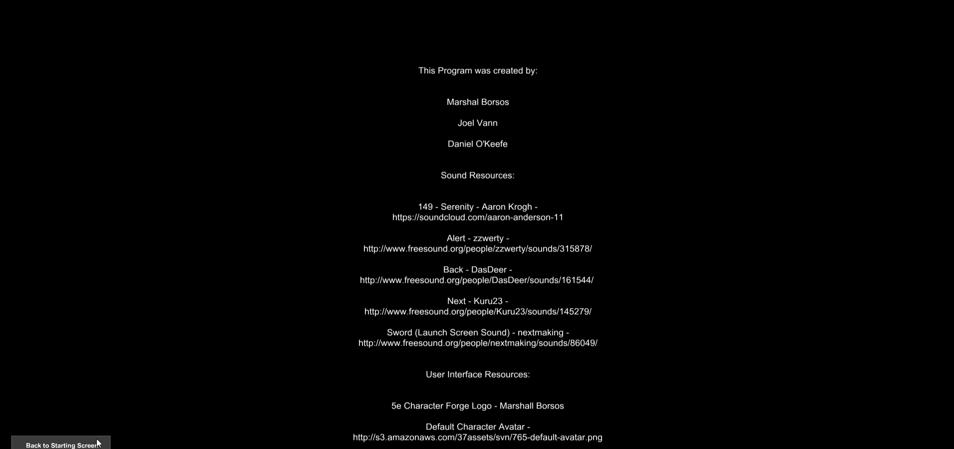

1. Exit Application

In order to exit the application, select the “Exit Application” button and select “Yes” in the popup which appears to confirm the ending of the application.

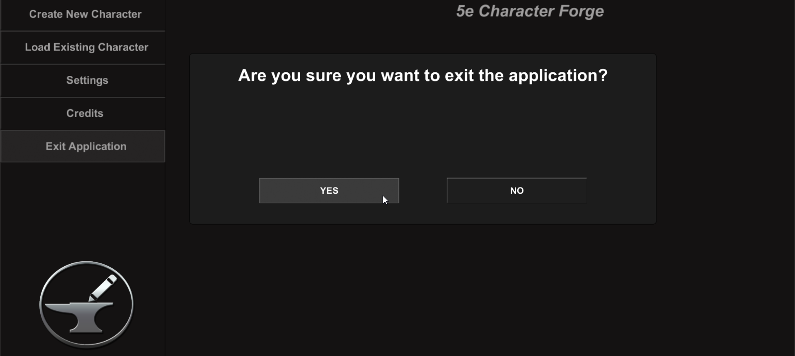

# Character Creation

After selecting the Create New Character button in the start or pause menu, the user will be directed to a new set of screens for character creation.

1. Uploading an Avatar

In order to upload an avatar image, the user clicks on the avatar image (see below) to display a popup.

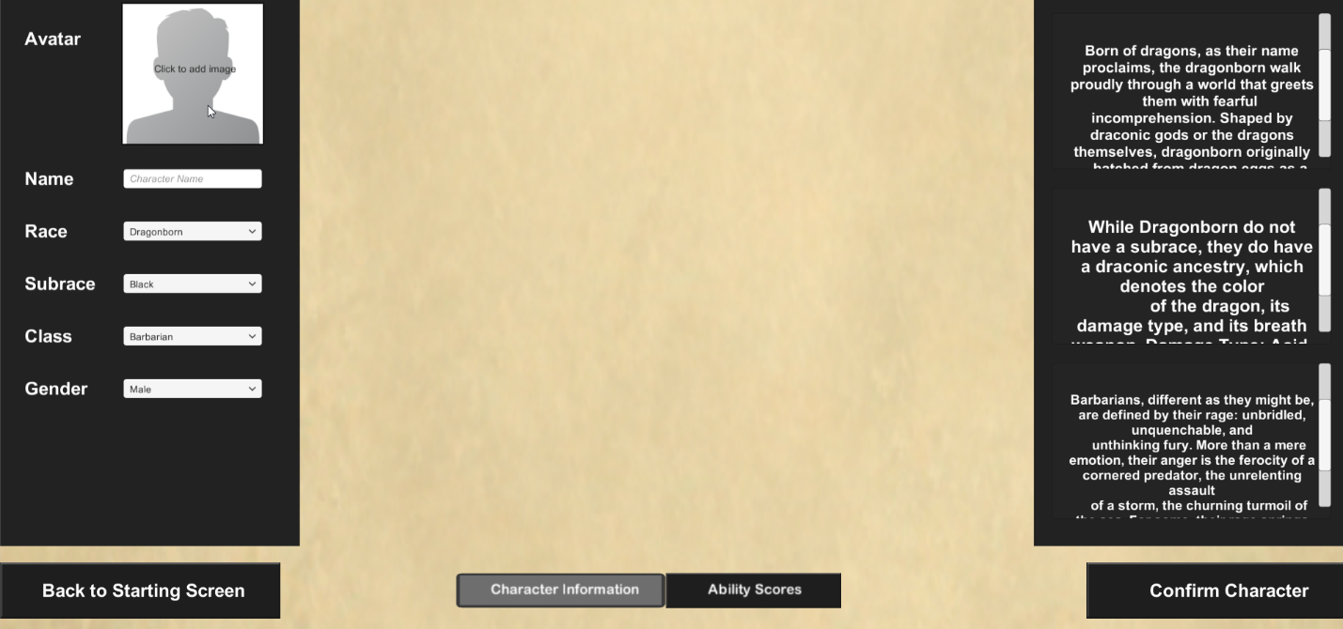

Within this popup, the user can either upload an avatar image from a URL or from a local file on his or her device.

* Via URL – enter the URL of the image and select the Upload button next to the URL field
* Via File – click the Browse button to search for the image to upload, select the image, then select the Upload button to the right of the Browse button

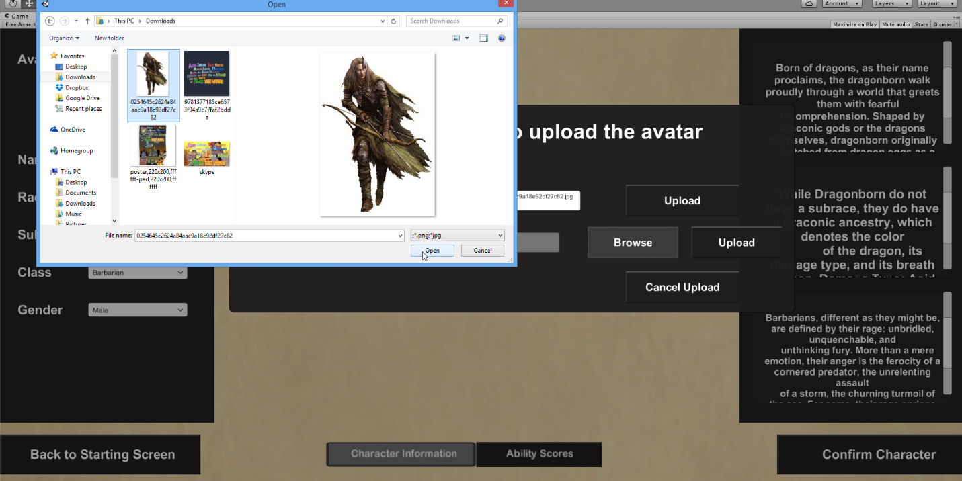Alternatively, the user can exit out of the uploading process by selecting the Cancel Upload button.

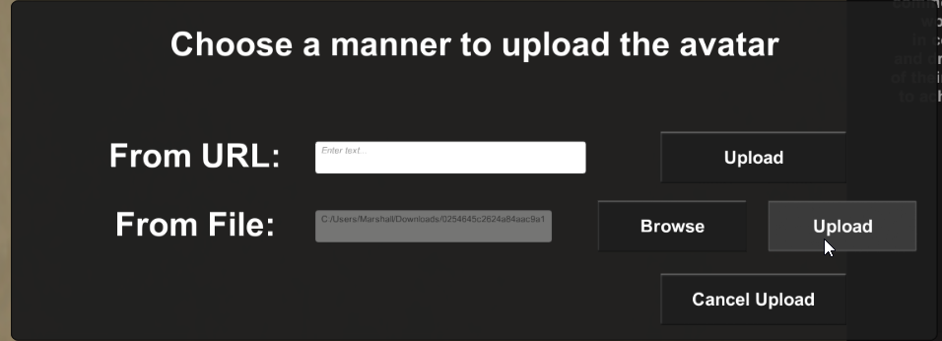



1. Enter Character Name

Enter a name for the character.

1. Select Race and Subrace

Select a race for the character. This selection will affect the character’s ability scores, proficiencies, and languages.

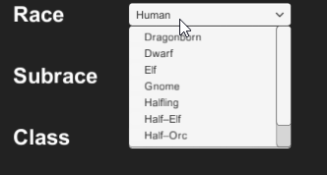

If the selected race has a subrace, then select a subrace for the character as well.



1. Select a Starting Class

Select a starting class for the new character. The character’s class will affect the spells they can learn, health, proficiencies, etc.

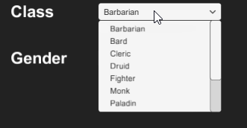

1. Select a Gender

Select a gender for the class (Male, Female, or Other).



1. Enter Ability Scores­­­­­­­­­

The next main part of the character creation process is to enter the starting ability scores of the character, which represent different stats (such as strength, wisdom, charisma, etc.).

There are two ways in which users can maintain ability scores:

1. 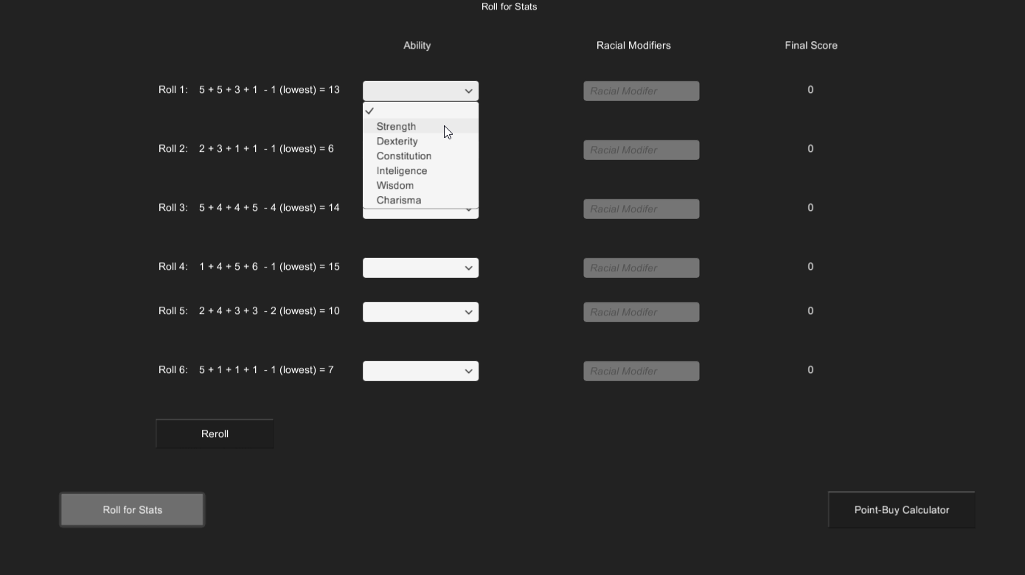Roll for Stats

The “Roll for Stats” method of assigning ability scores acts as the name suggests, in that the Reroll button can be used to perform dice rolls, and the results of the rolls can then be assigned to a particular stat. The user is able to decide which role can be used for a particular stat, which is especially useful if he or she is looking to make a particular build.

To assign an ability to a corresponding roll, select the desired dropdown (depicted above) and select the ability to be used for that certain score.

Note: Each ability can only be assigned once, and all abilities must be used.

Note: If an ability is selected, but it is already in use, the dropdown which already contained the ability will be reset.

1. Point-Buy Calculator  
     
   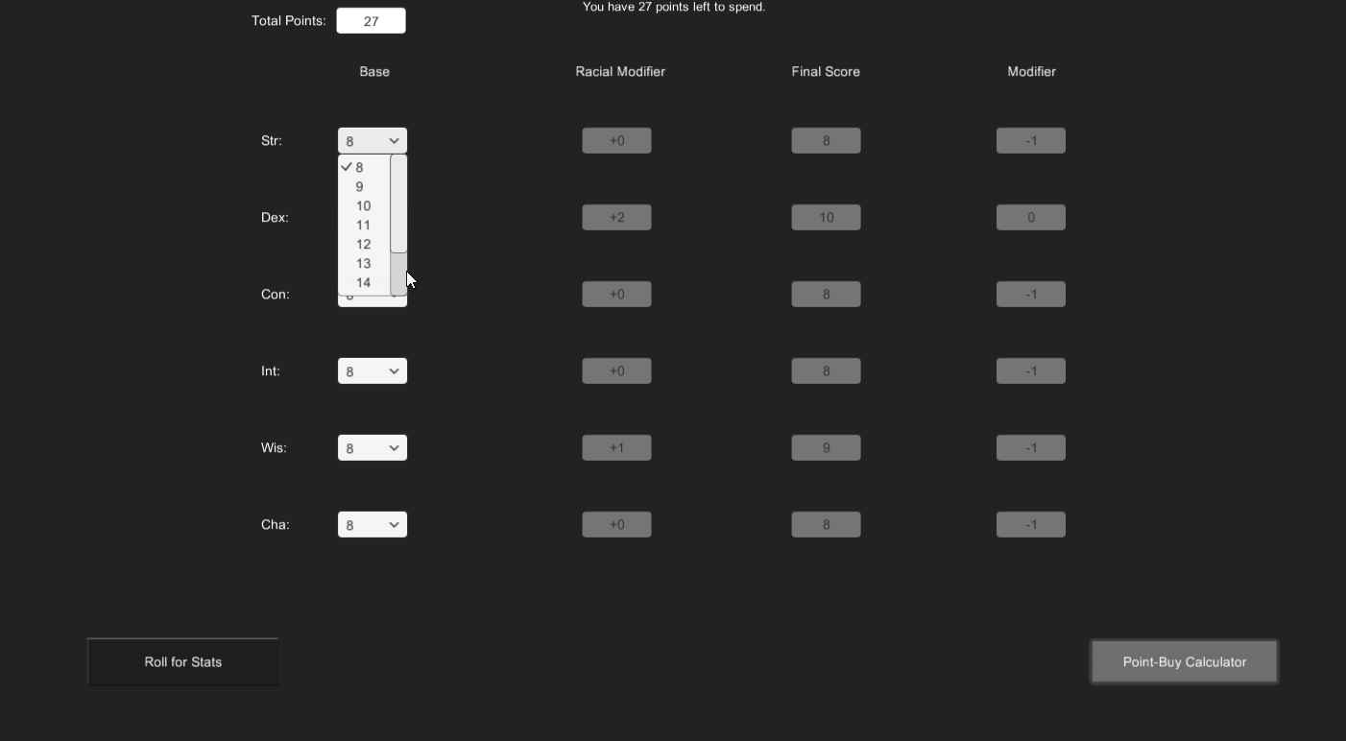

The Point-Buy Calculator allows for a more in-depth way for allocating ability scores. With this mode, the user begins with 27 points to allocate, and each ability starts with a base of 8 points. The user can “spend” the points given to him or her to increase the score of a particular ability, but the user can only spend an amount of points less than or equal to 27.

In order to allocate points, select the dropdown which corresponds to the ability whose score should be increased and select the desired value for the ability. These values can be adjusted in any order, and so long as the user has a number of remaining points greater than or equal to zero, he or she will be able to confirm the character when the Confirm Character button is selected.

Note that for both ways to edit ability scores, there is a racial modifier. This portion is based on the selected race and subrace which were maintained in the Character Information section.

Note: The ability scores which will be saved with the character are those which are in the last method the user used to calculate his or her ability scores (i.e., if the user is in the “Roll for Stats” mode, then the ability scores in the “Roll for Stats” mode will be saved, regardless of whether the user entered information in the “Point-Buy Calculator” mode.

1. Confirm Character

To confirm the character creation process, select the Confirm Character button and select Yes in the popup which displays to confirm the character.

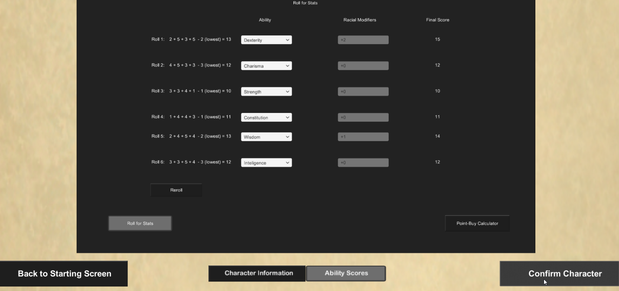

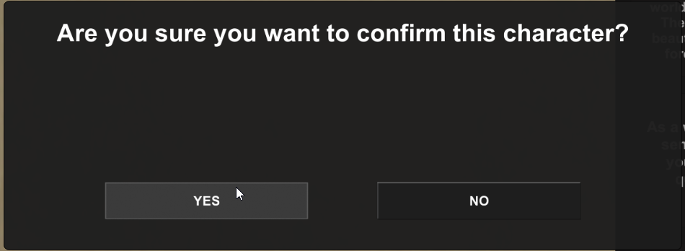

Note: In addition to the prerequisites set by the ability scores, the user is required to enter a name for the character in order to confirm character creation and save the character.

Once the user selects Yes, the character will be saved, and the user will be redirected to a new set of screens which will be used for maintaining the character from this point on.

# Character Maintenance

Maintenance of the character after the character creation phase is performed within the below “hub” of screens, which allows for the viewing and editing of the following information:

* Character Overview – character information (such as class, name, race, height, age, alignment, etc.)
* Spells – screen in which the user can view known spells and view and add unknown spells (according to restrictions imposed by the Dungeons & Dragons 5th Edition format
* Proficiencies – screen in which the user can view, add, and remove character proficiencies, which are bonuses to certain aspects of the character (such as lockpicking)
* Combat – allows the user to view and edit combat-related information (such as will, armor class (AC), base attack bonus, etc.), as well as equipped weapons, armor, and attuned items from the character’s inventory
* Feats – screen in which the user can maintain character feats, which are essentially special talents that differentiate the character from others
* Notes – allows for the user to add in notes about the character’s background, or information relating to the session the character is being used in
* Inventory – screen which allows for users to view and maintain both coinage (the amount of money the character has on his or her person), as well as the maintenance of the weapons, armor, potions, vehicles, and other categories of items which comprise the inventory of the character
* Dice roller – screen in which the user can simulate dice rolls by entering the sides on the dice and the number of dice being rolled

1. 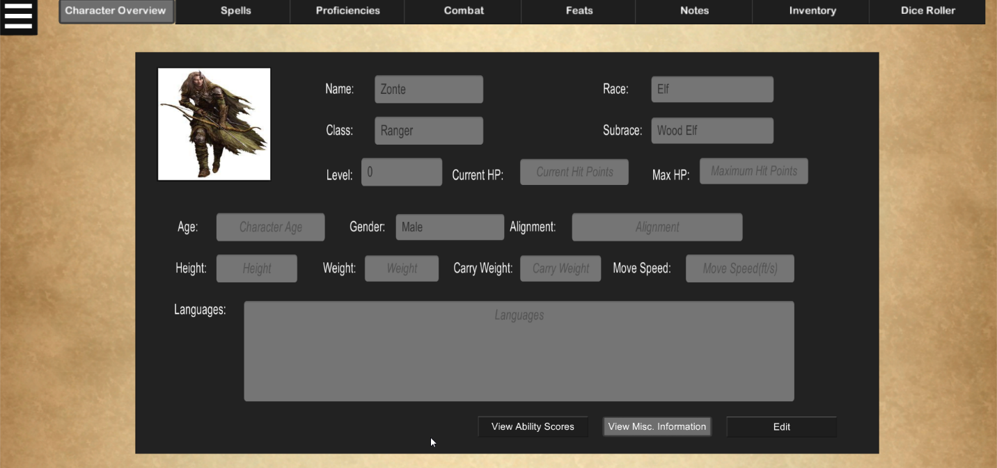Character Overview

The Character Overview section allows for the user to view his or her basic information and ability scores. Such information includes, but is not limited to, the character’s name, race, class, current level, current and maximum health, age, height, carry weight, and languages known. By default, this screen will begin in display mode and will be viewing miscellaneous information (such as age, gender, and weight). The user can view ability scores instead of the miscellaneous information by selecting the View Ability Scores button, and can switch back by selecting the View Misc. Information button.

If the user wishes to update information about the character, he or she can do so by selecting the Edit button to enter edit mode.

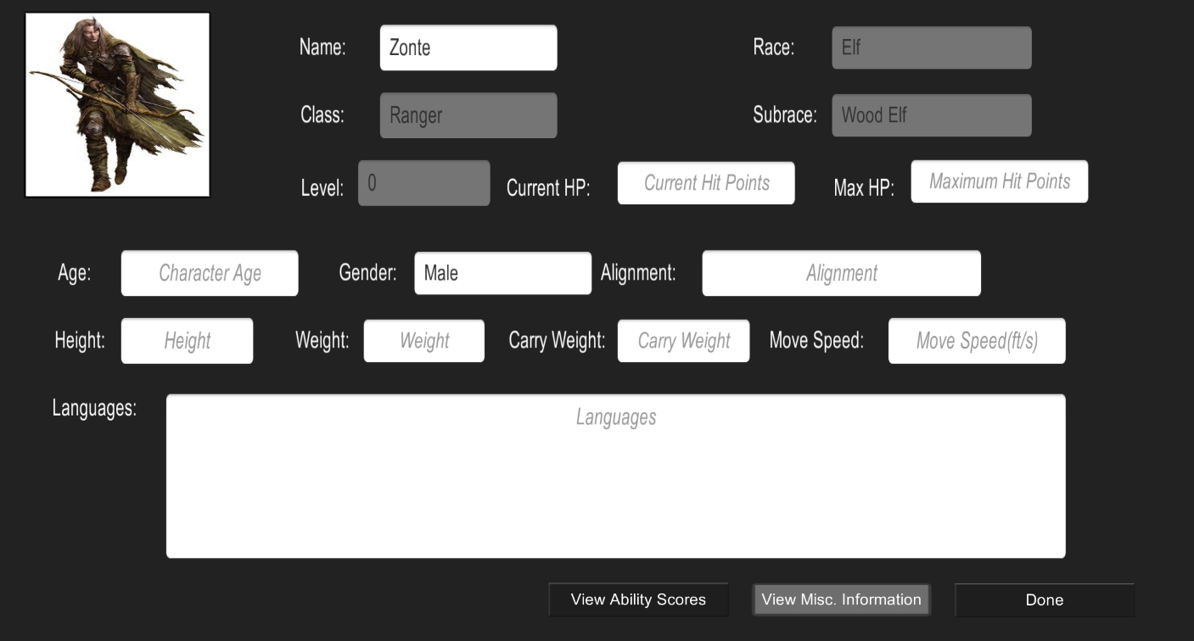

From here, all non-grayed fields, as well as the character avatar, are maintainable. Once the user is done editing, he or she can confirm his or her changes by selecting the Done button. Doing this ensures that when the character is saved that the changes done are saved.

1. Spells

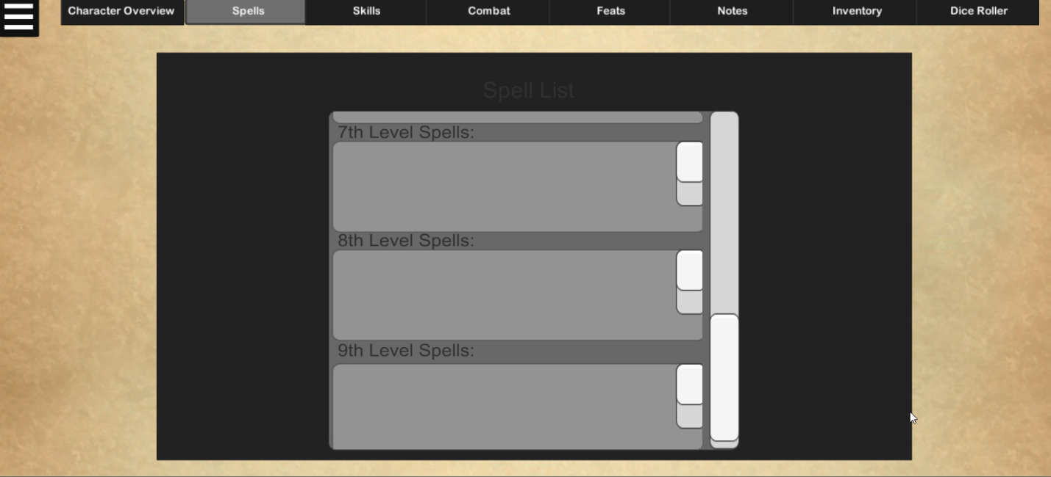

1. Proficiencies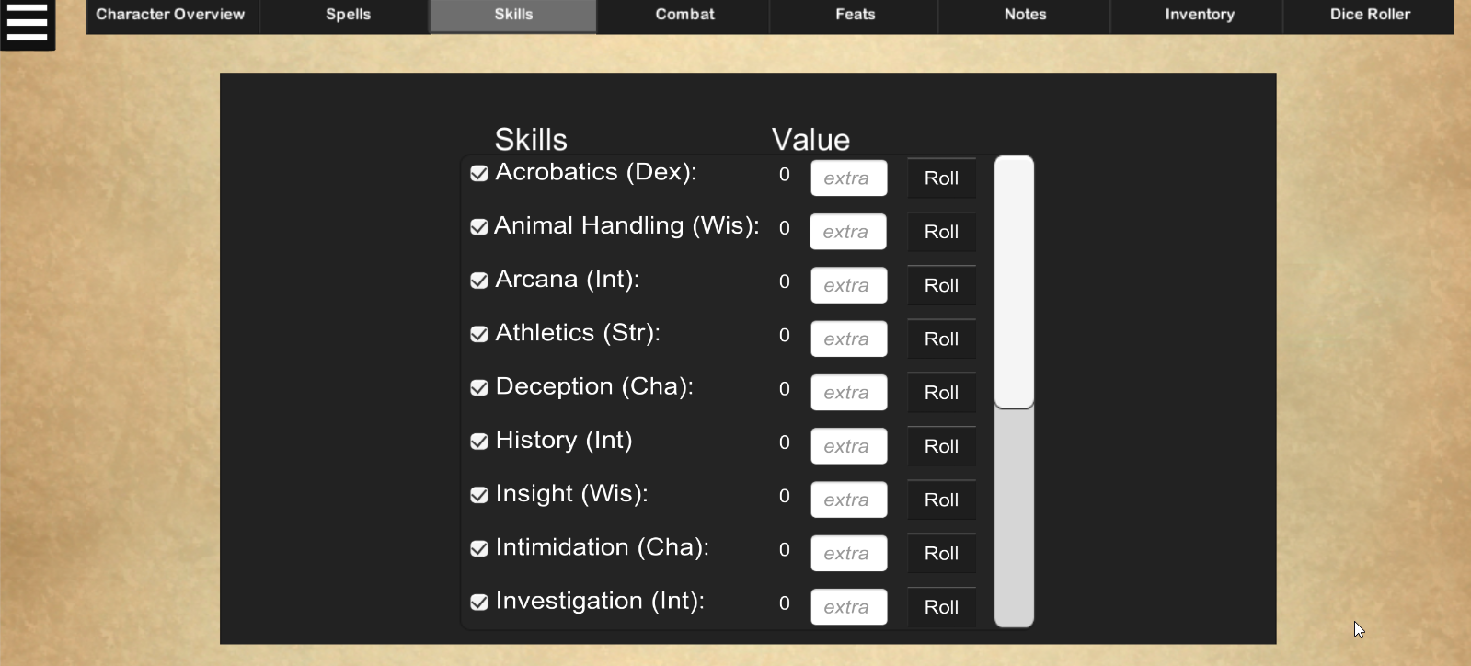
2. Combat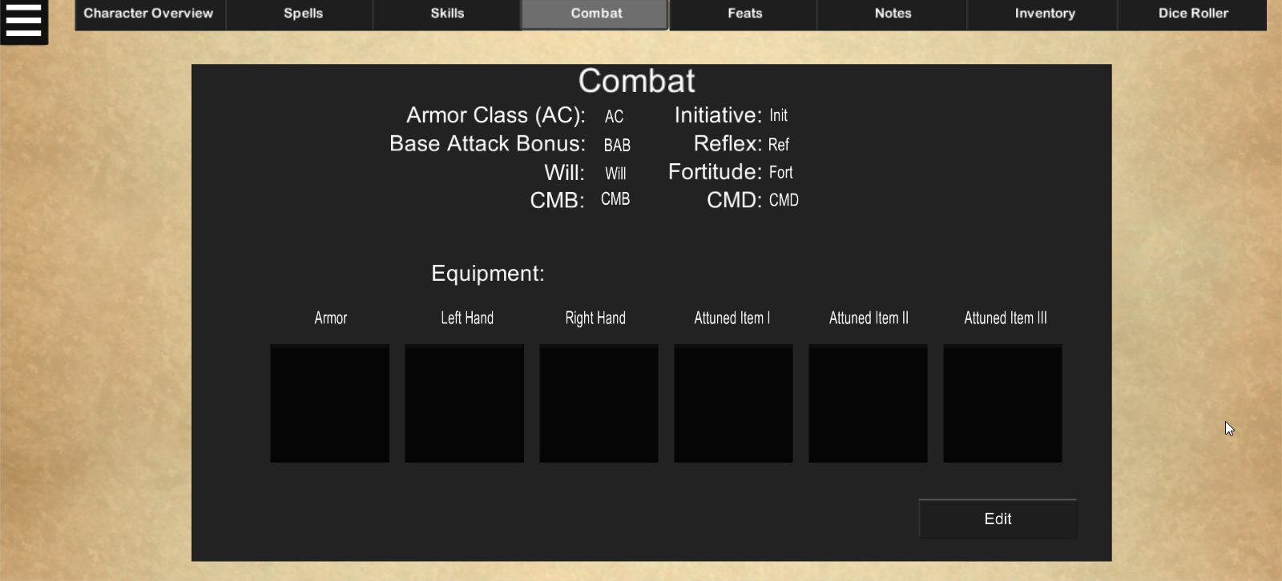

Within the combat section, the user can maintain information related to the character’s equipment and combat information. The top section contains information relating to combat, such as base attack bonus and armor class, while the bottom portion contains the character’s currently equipped items. To maintain information in this screen, select the Edit button in the bottom-right corner.

1. Maintaining Combat

Maintaining combat information is similar to how the character overview information is maintained. Therefore, update the desired fields and select the Done button in the bottom-right corner to confirm changes made.

1. Maintaining Equipment

While in edit mode, select the square button which corresponds to the type of item to be equipped. Doing this when no item is equipped in that spot will open a popup which will allow the user to view items within the character’s inventory so he or she can determine which item to equip. While in this popup, the category of items which display can be changed by using the provided Item Category dropdown. When an item is selected, the information about the item will be displayed, and the user can either back out by selecting the Cancel button or can add the item to the selected equipment slot by selecting the Equip Item button.

To remove an item, the user can select an equipment slot with an item assigned to it, and select the Unequip Item button. This allows the user to equip a different item in that slot if he or she wishes.

While in display mode, information about the item can be viewed by selecting the equipment slot of the desired item.

Note that equipped items will not appear in the character’s inventory, and items will need to be unequipped before their information can be changed or before the item can be deleted.

1. Feats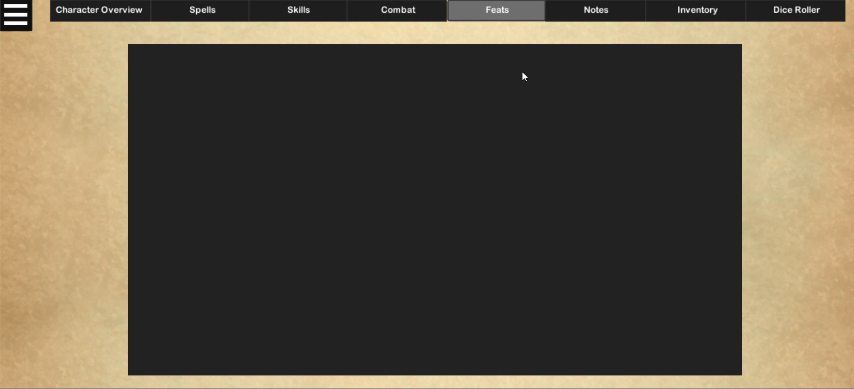
2. Notes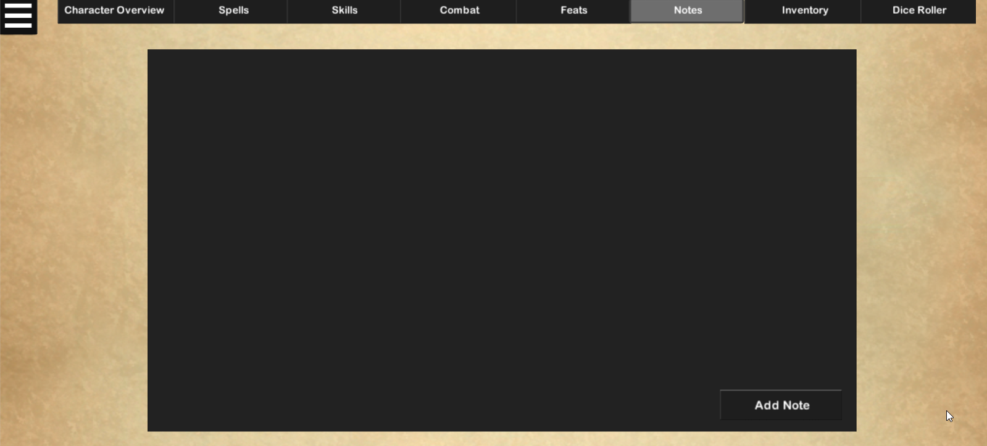

Within the Notes section, users can add entries for their character’s background or to record information about the session the character is involved in.

In order to add a note, the user selects the Add Note button. From here, the title, date on which the note relates to, and the subject of the note can be entered. Once these are filled, the Save button can be selected to save the note and add it to the list of the character’s notes.

Once this has been performed, the user can select the note in the list to edit its contents or delete the note from the list.

These notes will be saved when the user saves the rest of the character information.

1. Inventory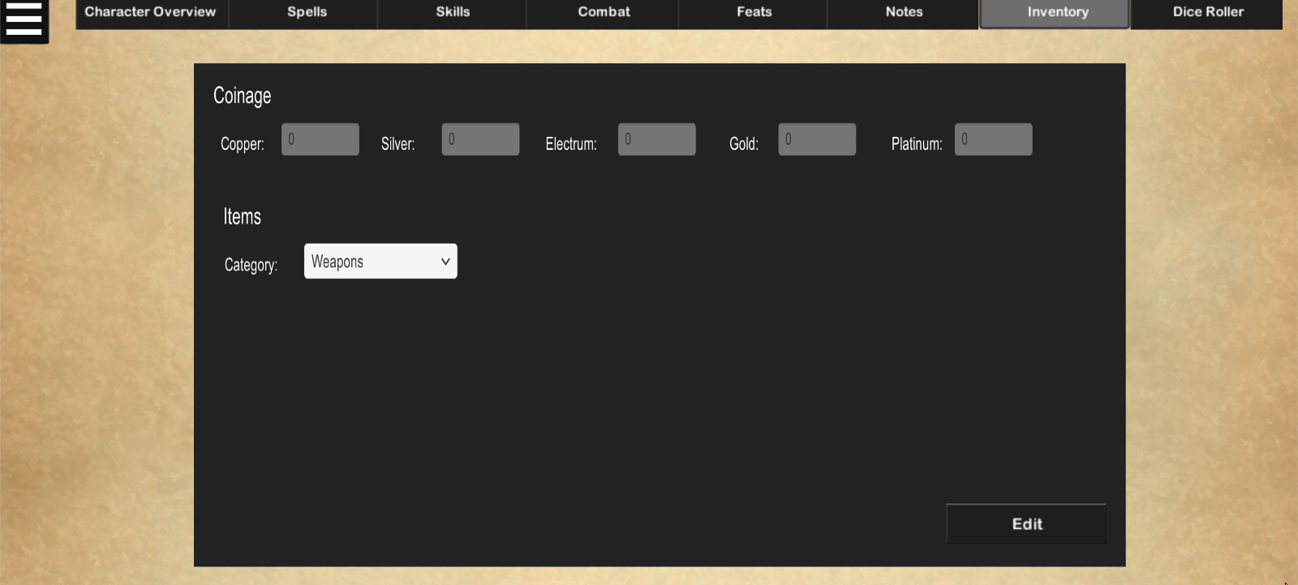

The inventory screen is where the user can maintain the amount of currency and items in his or her character’s possession. The Coinage section contains fields for each of the five types of currency in Dungeons & Dragons 5th Edition (copper, silver, electrum, gold, and platinum), while the Items section categorizes the character’s inventory into predefined categories. These categories are:

* Weapons
* Armor
* Poisons/Potions/Oils
* Vehicles
* Crafting Materials
* Miscellaneous

To change which item category to display, click the Category dropdown and select the desired category.

1. Maintaining Coinage

Maintaining the Coinage fields is the same as maintaining the character information and the combat information in that the user must enter edit mode, maintain the desired fields, and select the done button to confirm changes.

1. Maintaining Inventory

While the user is in edit mode, he or she can add and remove items by selecting the Add Item button. From here, the user can enter generic information about the item, such as name, description, weight, and cost. More specific information about the item can be maintained as well, and these fields will vary depending on the category selected in the Category dropdown. Once the item information is filled out to the user’s content, the user can save the item by selecting the Save button.

In order to view the added item, the user can select the item category of the item in the Category dropdown. If the item is clicked, the user can view its information – and, if the user does this in edit mode, the item information can be updated, or the item can be deleted by selecting the Delete Item button.

1. Dice Roller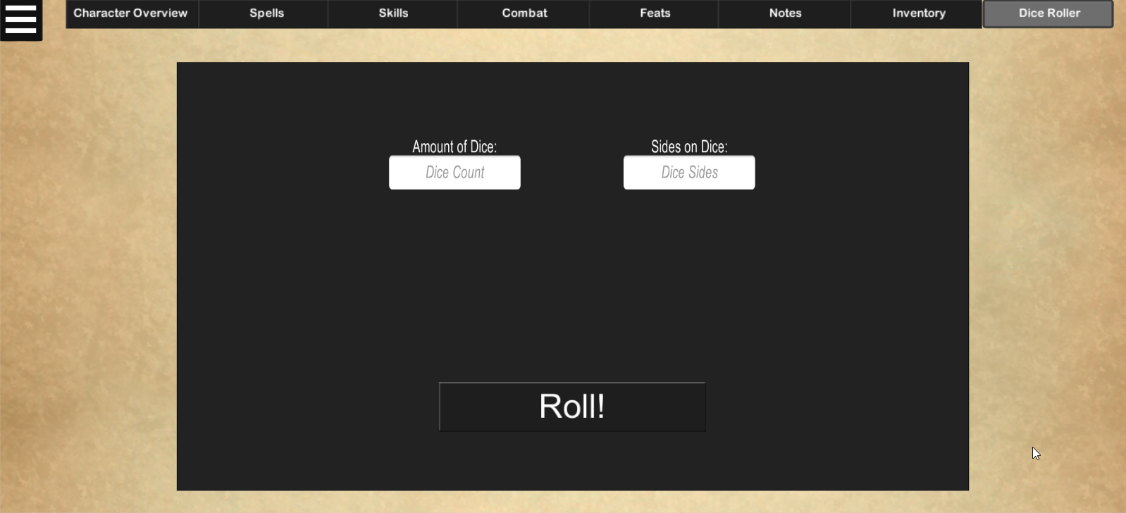

The dice roller screen allows for users to perform dice rolls without the need of physical dice. In order to do this, enter the amount of dice to roll and the number of sides each dice has, then select the Roll! button to see the results of each roll and their total.

Note that the sides of the dice is the same for each dice being rolled, and that it is not possible to roll dice with a differing amount of sides in the same roll.

1. Additional Functions
2. Using the Pause Menu

The pause menu can be opened by selecting the button in the top-left of the screen.



This screen is formatted similarly to the main menu, but there are some new functions which can be chosen:

* Save Character – saves the changes done to the character (according to the specifications described in the explanation of each screen)
* Delete Character – deletes the current character after the user selects Yes in a confirmation prompt

The other options in the pause menu act the same as they do in the start menu, with a couple of minor changes. If the user attempts to create a new character or tries to load an existing character, the user will need to select Yes in a prompt which asks if the user wants to continue, and notifies him or her that all unsaved changes to the character will be lost. 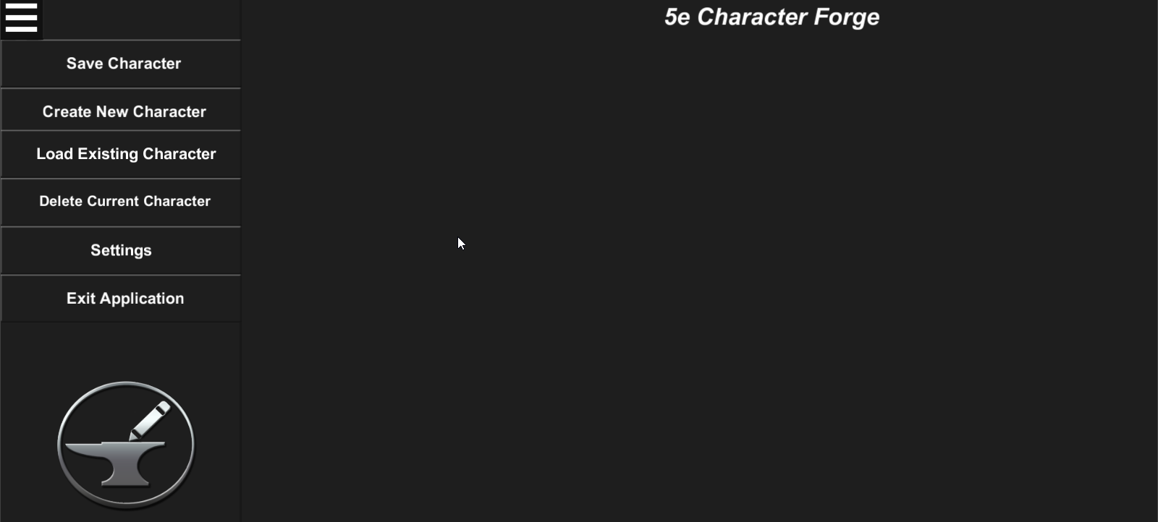

1. Saving the Character

In order to save changes done to the character, select the Save Character button. The user will be informed that the save was successful, and will be able to continue with character maintenance afterward.

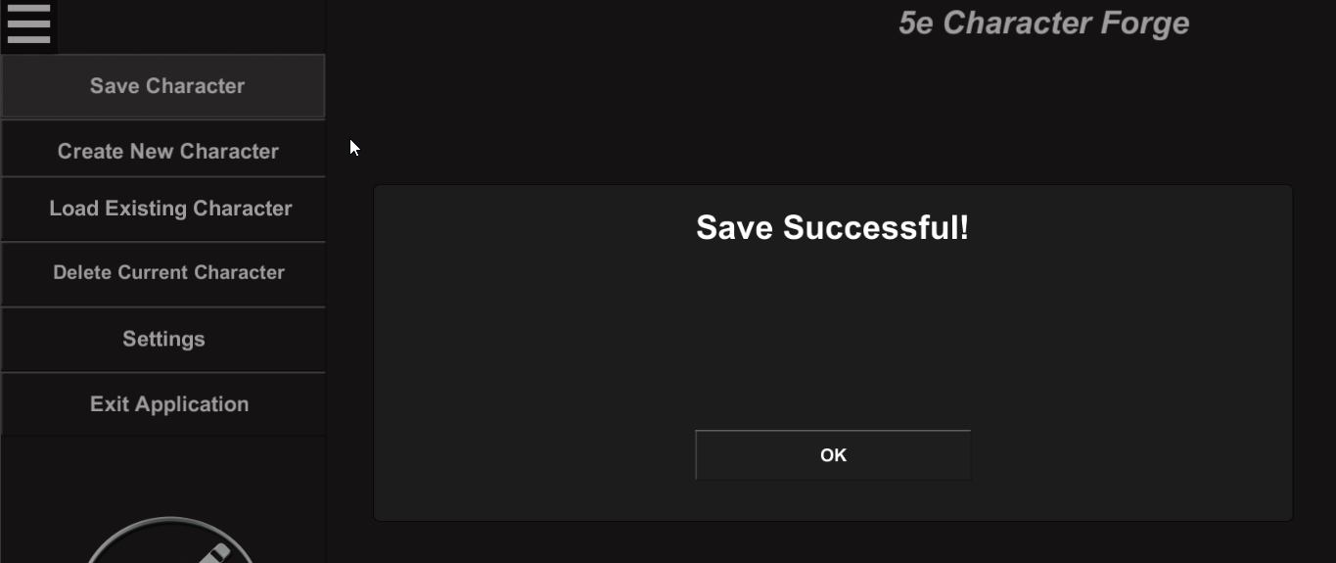

1. Load Existing Character

In order to load a previously saved character, select the Load Existing Character button to display a list of the possible characters to load. When a character from this list is selected, the user will be informed that unsaved changes to the current character will be lost. If the user selects Yes, the selected character will be loaded.

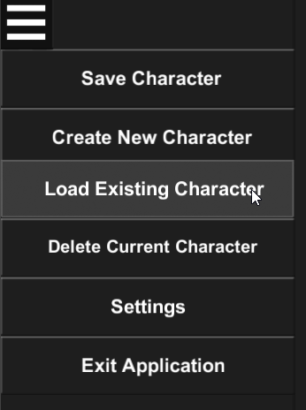

1. Delete Current Character

In order to delete the currently selected character, select the Delete Current Character button, which will cause a prompt to display, warning the user that if he or she continues, there will be no way to recover its data.

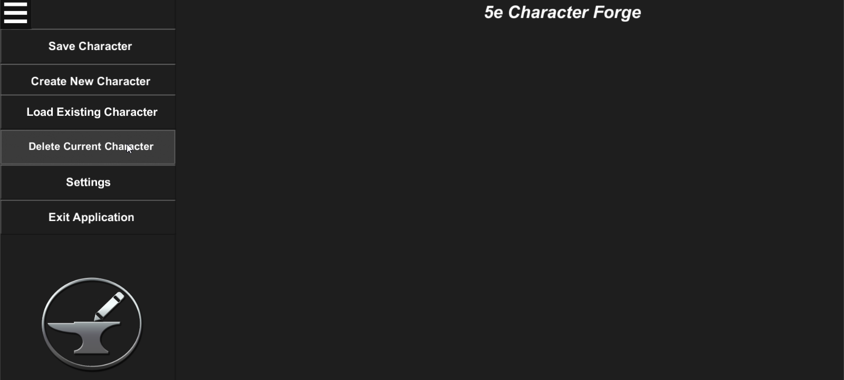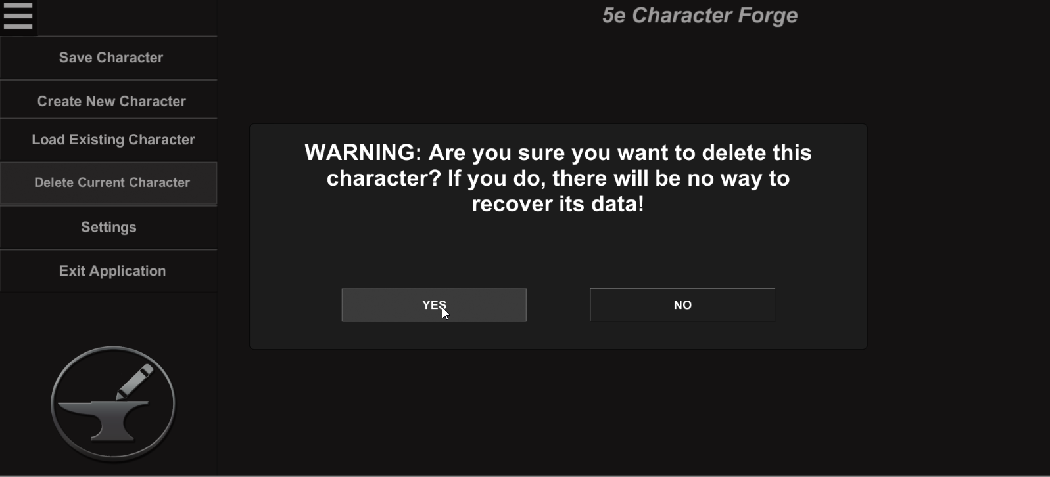

1. Closing the Pause Menu

In order to close the pause menu, select the same button in the top-left corner of the screen which was used to open the pause menu.



# Maintaining Settings

In order to maintain universal settings, the user can select the Settings button in either the pause or start menus.

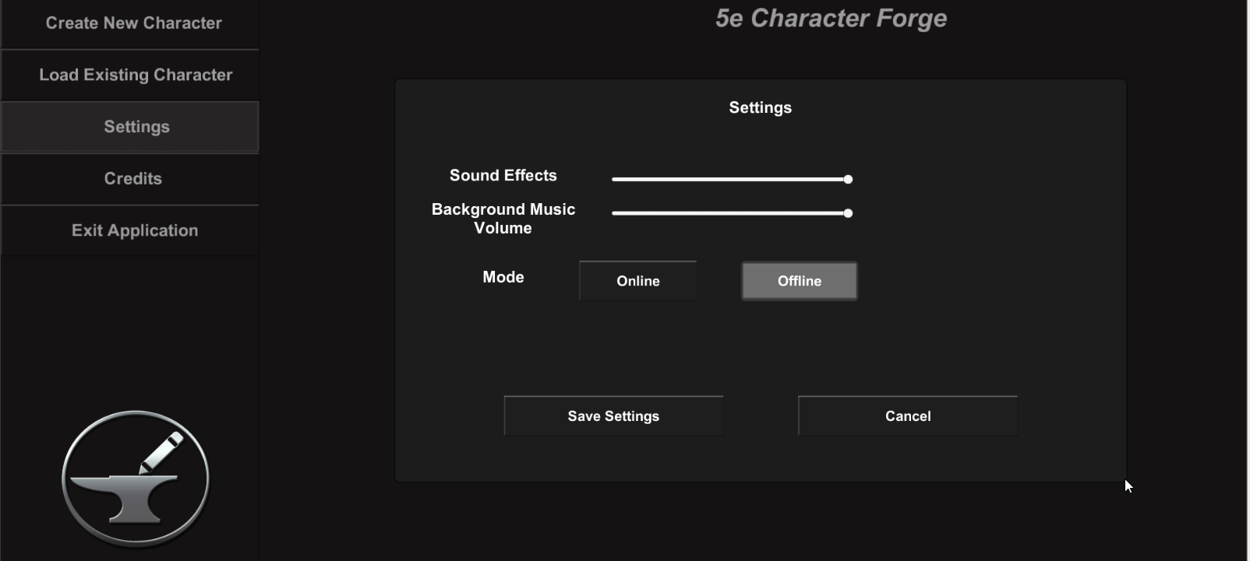  
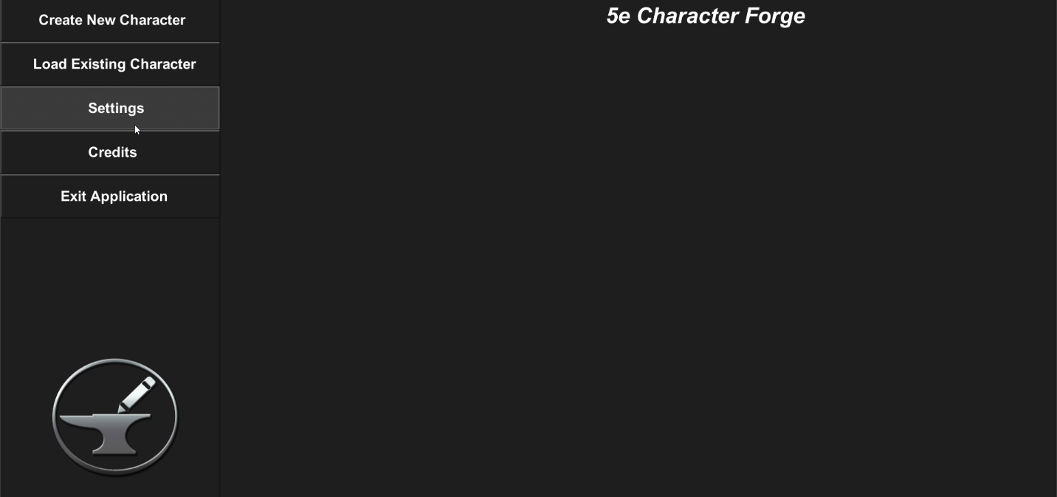From here, the user can adjust the application’s volume for the background music, volume for sound effects (such as button clicks and alert notifications), and change the mode to either online or offline.

To adjust the volumes, use the corresponding sliders in the settings menu. Moving the slider left will decrease the volume, while moving the slider to the right increases the volume.

There are two modes for the 5e Character Forge application:

* Online – data retrieved from external resources (such as the class, race, and spell descriptions) will be retrieved from the internet
* Offline – data retrieved from external resources will be retrieved from local files which are stored on the computer (allows for offline use in case the user loses his or her internet connection)

When a mode is selected, the user will be warned of how the change will affect the application:

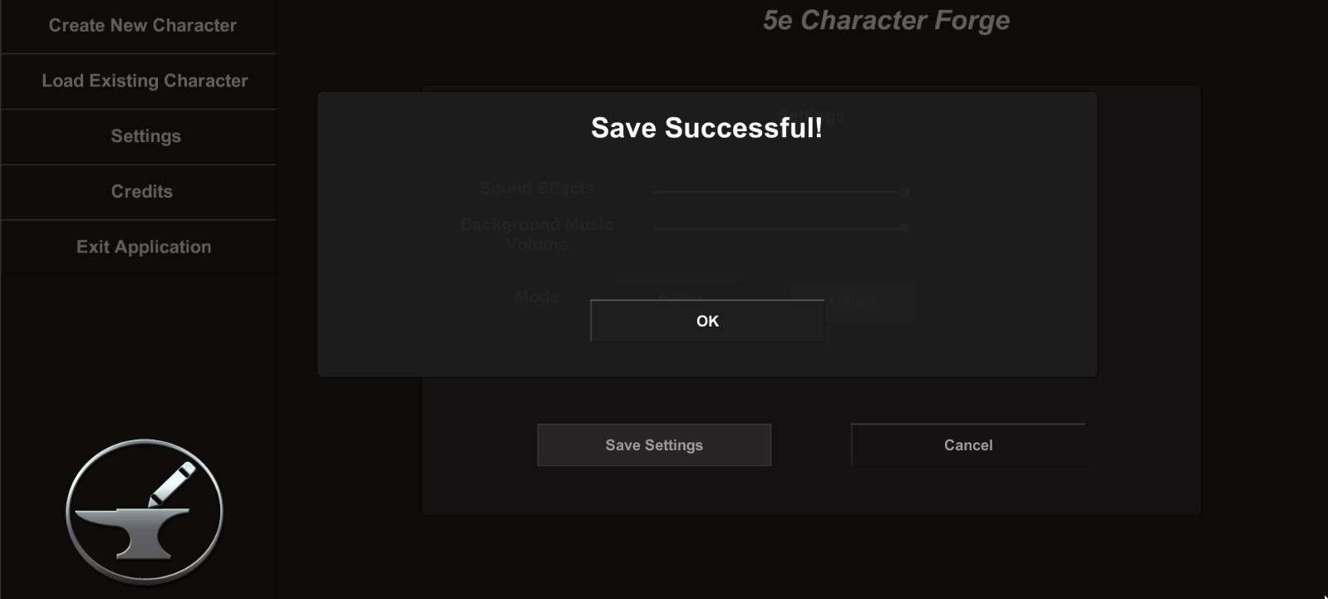Once the user is satisfied with his or her changes, he or she can save said changes by pressing the Save Settings button:

Alternatively, the user can cancel changes by selecting the cancel button.